**World Quant University**

**Professor: Ritabrata Bhattacharyya**

**Python II**

Nikolas Lippmann Pareschi - [nikolaslippmann@gmail.com](mailto:nikolaslippmann@gmail.com)

**Project 4:  How Do Markets React to Republicans and Democrats?**

Introduction: I have used PIP8 check and have made the check through Conda Prompt in the last project. This time I read in Piazza that I could do that in Spyder, which was truly a time saver:

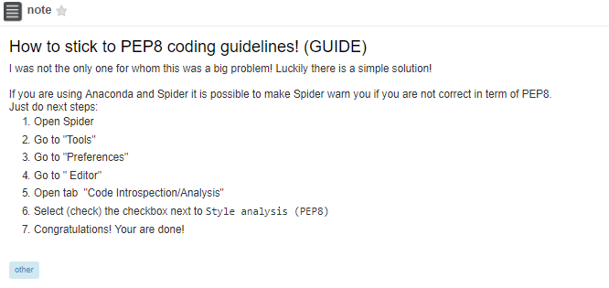

* + 1. Create a csv file with a list of all presidents, their parties from 1920 onwards

Created CSV file:

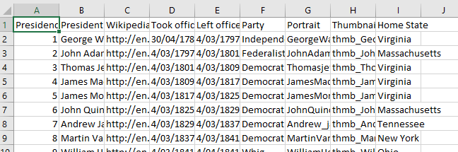

* + 1. Using Pandas load the .csv file into a Pandas dataframe.



* + 1. Download data from an appropriate financial website such as Google Finance, Yahoo Finance, Quandl, CityFALCON, or another similar source.

For this step I used Quandl. I have the impression that Yahoo has abandoned a little bit his tool for market analysis. Their data was very limited in a span of a few years. Yahoo was bought by Verizon recently for 4.5 billions, a value a lot lower than the top market cap value of Yahoo (125 billions).

<https://tech.slashdot.org/story/16/07/25/1133257/once-valued-at-125b-yahoos-web-assets-to-be-sold-to-verizon-for-483b-companies-confirm>

Maybe it is safer to stick to Quandl and Google from now.

For that purpose, I used pandas:



* + 1. Calculate yearly returns for both the downloaded indices from 1920 onwards



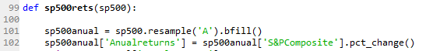

* + 1. Segregate returns in terms of Presidency – i.e. stock market returns during Democratic and Republican years

DJ:

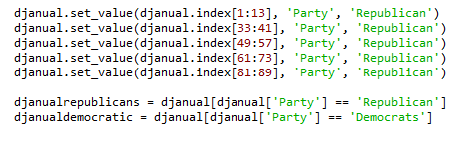

I decided to do SP500 monthly returns to be a little different from DJ analysis, which is higly correlated to SP500 mainly in the beginning when we had fewer shares.

SP500 (Monthly):

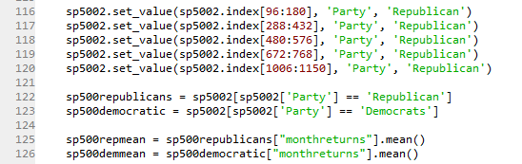

* + 1. Calculate measures of central tendency (mean return, median return, variance of returns) for each of the two groups.

DJ

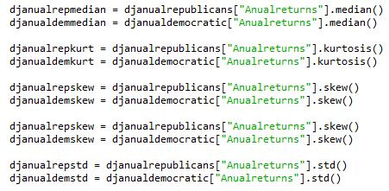

SP500

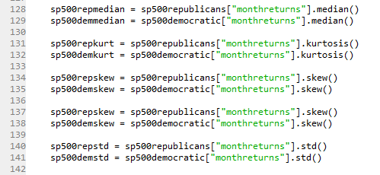

* + 1. Represent the findings through suitable comparative graphical studies

